Career Exploration with Major Clarity

Directions:
- Go to platform.majorclarity.com

- Scroll below the Sign In box & choose “Continue with Google.”

- This will take you to your WakeID portal to log in then it will direct you back to Major Clarity.

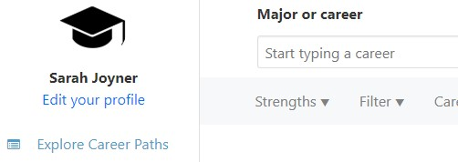
- Click on Explore Career Paths
  - Type in Major or Career of Interest
OR
  - Browse Career Paths

- Explore a Pathway and complete the first column in the chart below

- Explore a second pathway and complete column two below.

DIRECTIONS: Choose the career path that most interests you. | CAREER PATH I | CAREER PATH II
Career Path
Briefly describe this career path:

What Career Cluster does this path fit into?
What is the starting salary range for this path?

List some careers that fall into this career path that only require an associate degree:
DIRECTIONS: Choose the career path that most interests you. | CAREER PATH I | CAREER PATH II
List some careers that fall into this career path that require a bachelor’s degree or higher:
Select a career from the list above based on the education level that you plan to complete and answer the questions below: Career Title: __________________________________________________________________________

- List 3 of the common tasks done in this career.
a)
b)
c)
- What is the Annual Average Salary?

- What education level do most people in this career have?

- What is the Job Growth for this career?

- What areas of knowledge are needed for this career?

- What skills are needed for this career?

- Were the two career pathways like what you thought, or were they different from what you expected? How so?

